Filling Type: DEF 14A (latest);

<https://www.sec.gov/Archives/edgar/data/815097/000119312518068247/d499010ddef14a.htm>

Check for an image and following bolded headlines

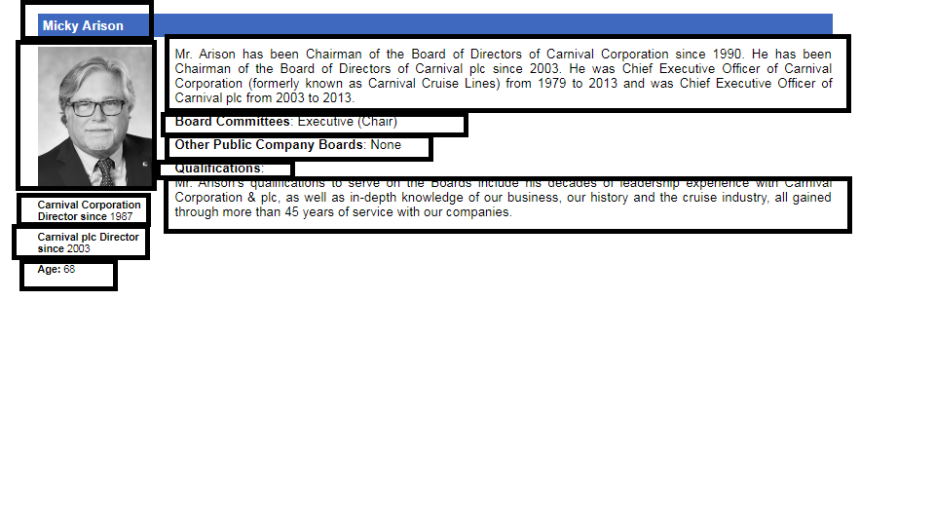

**Check for keyword: Director Compensation for Fiscal 2017**

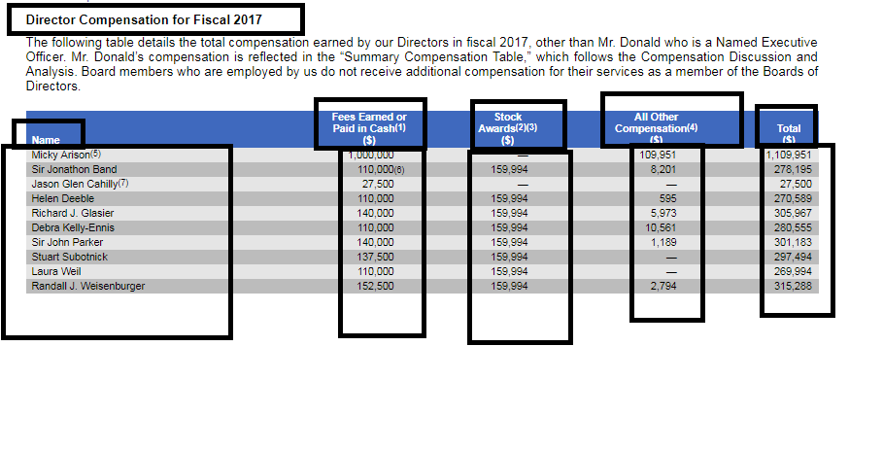

Check for keyword: **Board Committees**

The current Board Committee members are as follows:

